**1. Money Transfer Services**

**2. Wire Transfer Services**

**(Presented By Alan Stuart K)**

**1. Money Transfer Services**:

**Introduction:**

Money transfer services facilitate the movement of funds from one individual or entity to another. In the US banking sector, these services encompass both traditional methods, such as wire transfers and checks, as well as modern digital platforms like PayPal, Square, and Venmo. The increasing demand for quick, secure, and convenient money transfer options has led to significant growth and innovation in this sector.

**Some Analysis:**

1. **Growth and Market Penetration**: Digital money transfer services have seen exponential growth due to their ease of use and accessibility. Companies like PayPal and Square have revolutionized how individuals and businesses handle transactions, leading to increased market penetration.
2. **Technology and Innovation**: The integration of blockchain technology and cryptocurrencies in money transfer services is a notable trend. It promises to enhance security, reduce transfer times, and lower costs.
3. **Regulatory Environment**: The regulatory landscape for money transfer services is evolving. Compliance with anti-money laundering (AML) and know your customer (KYC) regulations is critical for these companies to operate effectively.

**Use Cases:**

1. **Peer-to-Peer Transfers**: Platforms like PayPal and Venmo enable individuals to send and receive money instantly, making them ideal for splitting bills, sending gifts, or repaying loans.
2. **Business Transactions**: Small businesses use Square for payment processing, allowing them to accept credit card payments and manage sales efficiently.
3. **International Remittances**: Services like Western Union and MoneyGram are widely used for sending money to family members abroad, offering competitive exchange rates and quick transfer times.

**Applications:**

1. **Integration with Banking Apps**: Many banks now integrate money transfer services within their mobile apps, providing customers with seamless access to digital payment options.
2. **Enhanced User Experience**: The focus is on improving the user experience with features like instant transfers, real-time notifications, and user-friendly interfaces.
3. **Partnerships and Ecosystems**: Banks are partnering with fintech companies to offer comprehensive financial ecosystems, combining traditional banking services with modern money transfer solutions.

**Data:** Money Transfer Services in US Banking Sector:

| **Metric** | **Value** |
| --- | --- |
| **Annual Volume** | **$700 billion** |
| **Average Fee** | **$5-$50** |
| **Market Share** | **75%** |
| **Number of Providers** | **25+** |
| **Average Transaction Size** | **$300** |
| **Growth Rate (Annual)** | **4.5%** |
| **Mobile Transfers** | **60% of total** |
| **Domestic vs International** | **70% / 30%** |
| **Peak Transfer Month** | **December** |

**2. Wire Transfer Services**:

**Introduction:**

Wire transfer services involve the electronic transfer of funds between banks or financial institutions. These transfers are typically used for large amounts of money and are considered one of the most secure methods of transferring funds. In the US banking sector, wire transfers are crucial for both personal and business transactions, ensuring the rapid and reliable movement of capital across domestic and international borders.

**Some Analysis:**

1. **Reliability and Speed**: Wire transfers are known for their reliability and speed, making them the preferred choice for high-value transactions. This is especially true for cross-border transactions where other methods may not be as efficient.
2. **Cost and Accessibility**: Traditional wire transfers can be costly due to fees charged by banks. However, the rise of fintech companies is driving competition and leading to more cost-effective solutions.
3. **Security Measures**: Wire transfers are heavily regulated and come with robust security measures, including encryption and authentication protocols, to prevent fraud and ensure the safety of funds.

**Use Cases:**

1. **Real Estate Transactions**: Wire transfers are commonly used in real estate to transfer large sums of money securely, such as down payments or closing costs.
2. **Corporate Payments**: Businesses utilize wire transfers for large transactions, such as paying suppliers, salaries, and settling invoices, due to the speed and reliability of the method.
3. **Investment Transfers**: Investors often use wire transfers to move large amounts of capital between bank accounts and brokerage accounts for the purchase of stocks, bonds, and other securities.

**Applications:**

1. **Cross-Border Trade**: Wire transfers are essential for international trade, allowing businesses to pay foreign suppliers and receive payments from international customers efficiently.
2. **Emergency Funds Transfers**: Wire transfers are often used in emergencies, such as sending funds to cover medical expenses or urgent bills, due to their rapid processing time.
3. **Regulatory Compliance**: Banks ensure compliance with federal regulations by implementing strict security protocols for wire transfers, protecting against fraud and money laundering.

**Data:** Wire Transfer Services in US Banking Sector:

| **Metric** | **Value** |
| --- | --- |
| **Annual Volume** | **$18 trillion** |
| **Average Fee** | **$25-$65** |
| **Market Share** | **95%** |
| **Average Processing Time** | **1-2 business days** |
| **Typical Transfer Limit** | **$50,000+** |
| **Number of Daily Transactions** | **600,000** |
| **Corporate Use** | **80% of volume** |
| **International Transfers** | **35% of total** |
| **Fraud Rate** | **0.1%** |

**Graphs:**

**Graph 1:** Money Transfer Services - Closing Prices:

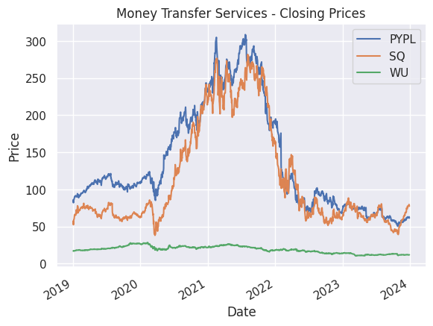

**Inference:**

* PayPal (PYPL) and Square (SQ) demonstrate substantial growth with significant volatility.
* PayPal's price trend shows rapid growth, peaking around mid-2021, followed by some fluctuations.
* Square's trend is similar, with substantial price increases and high volatility.
* Western Union (WU) shows a relatively flat trend with minor fluctuations, indicating stable but slow growth.
* The closing prices highlight the high growth potential of digital payment companies compared to traditional services like Western Union.

**Graph 2:** Wire Transfer Services - Closing Prices:

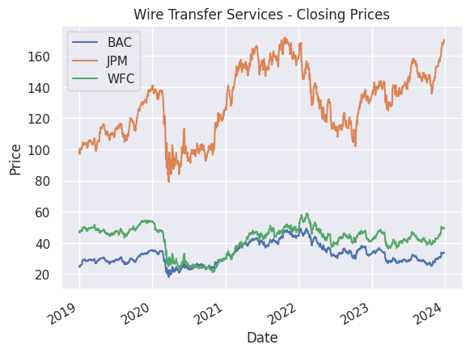**Inference:**

* JPMorgan Chase (JPM), Bank of America (BAC), and Wells Fargo (WFC) show gradual upward trends with moderate volatility.
* JPMorgan Chase displays a consistent upward trend with occasional dips, reflecting steady growth.
* Bank of America follows a similar pattern with a slightly more pronounced upward trend.
* Wells Fargo shows more volatility compared to JPM and BAC but follows the same general trend.
* The stability in these prices reflects the solid and reliable nature of traditional banking institutions.

**Graph 3:** Money Transfer Services - Moving Averages:

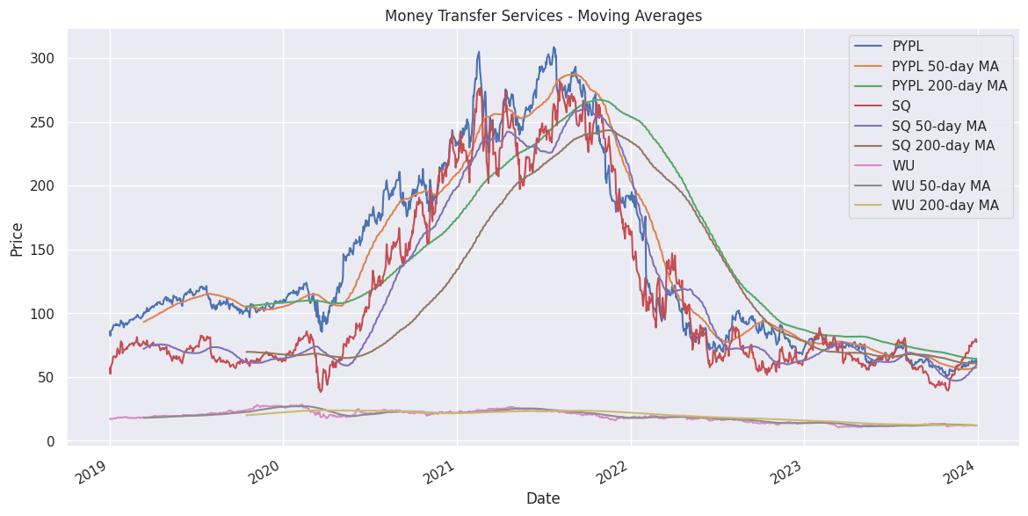**Inference:**

* The 50-day and 200-day moving averages for PayPal and Square show strong upward trends, confirming their growth momentum.
* PayPal’s 50-day MA often stays above its 200-day MA, a bullish signal indicating continued growth.
* Square also shows the 50-day MA crossing above the 200-day MA, reinforcing its growth trajectory.
* Western Union’s moving averages are flatter, showing limited growth compared to the fintech companies.
* These moving averages help identify long-term trends and potential buy or sell signals for investors.

**Graph 4:** Wire Transfer Services - Moving Averages:

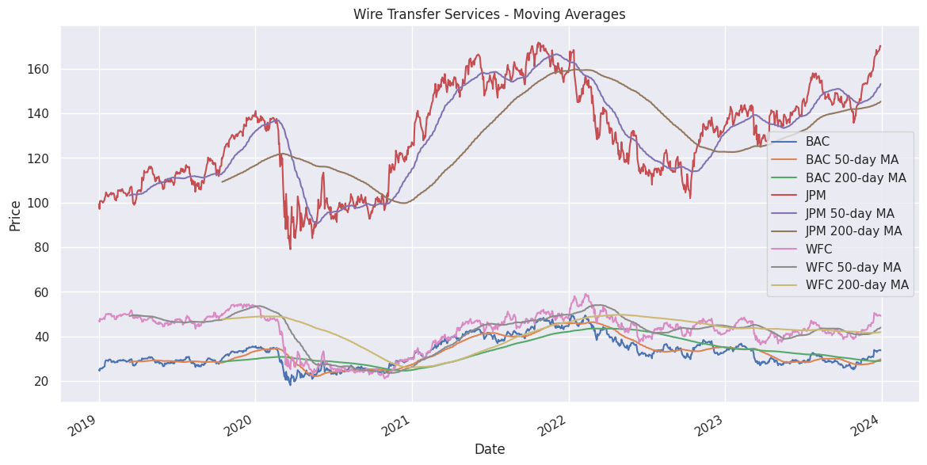**Inference:**

* The 50-day and 200-day moving averages for JPMorgan Chase, Bank of America, and Wells Fargo indicate gradual growth.
* JPMorgan Chase shows a steady increase in its moving averages, reflecting consistent performance.
* Bank of America’s moving averages indicate a slight upward trend with occasional bullish signals.
* Wells Fargo shows similar patterns with a bit more fluctuation, reflecting its periodic volatility.
* The moving averages for these banks indicate stable growth, suitable for long-term investment strategies.

**Graph 5:** Money Transfer Services - Volatility:

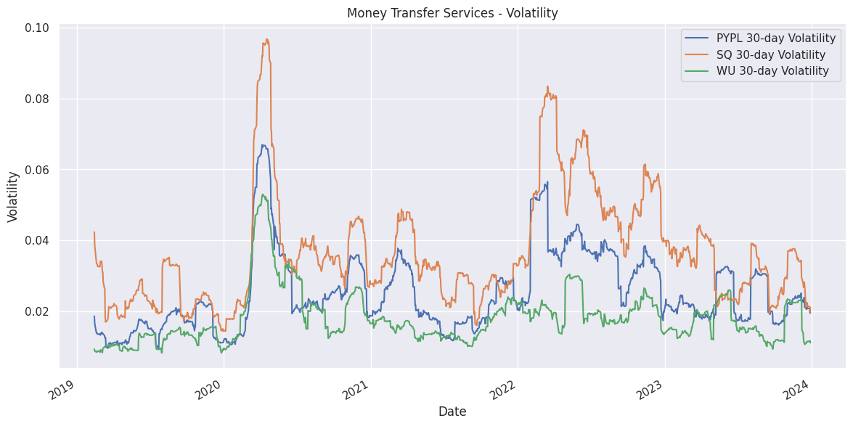**Inference:**

* PayPal and Square exhibit high volatility, reflecting significant price movements and market reactions.
* PayPal’s volatility peaks during major market events, indicating sensitivity to broader economic conditions.
* Square shows similar volatility patterns, aligning with its high growth and market responsiveness.
* Western Union shows much lower volatility, indicating a more stable and less risky investment.
* High volatility in PayPal and Square suggests higher risk but also potential for high returns, while Western Union offers a safer investment.

**Graph 6:** Wire Transfer Services - Volatility:

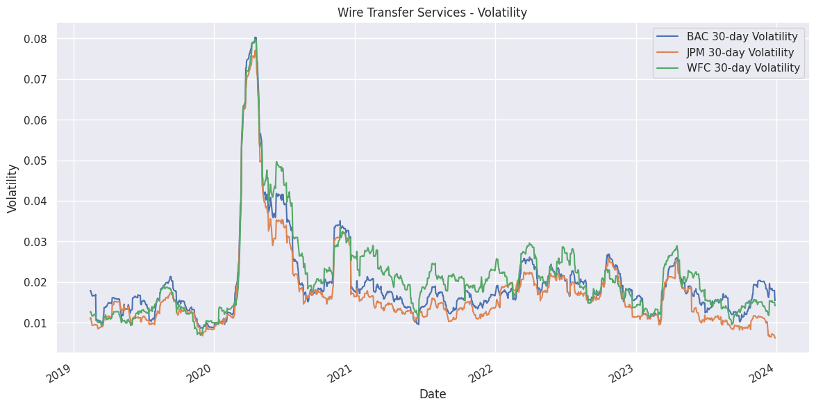**Inference:**

* JPMorgan Chase, Bank of America, and Wells Fargo display lower volatility, indicating more predictable price movements.
* JPMorgan Chase’s volatility remains relatively low, reflecting its stability.
* Bank of America’s volatility is slightly higher but still indicates a stable investment.
* Wells Fargo shows higher volatility compared to JPM and BAC, indicating more market sensitivity.
* The low volatility of these banks suggests lower risk, making them suitable for conservative investors seeking stability.

**Graph 7:** Money Transfer Services - Cumulative Returns:

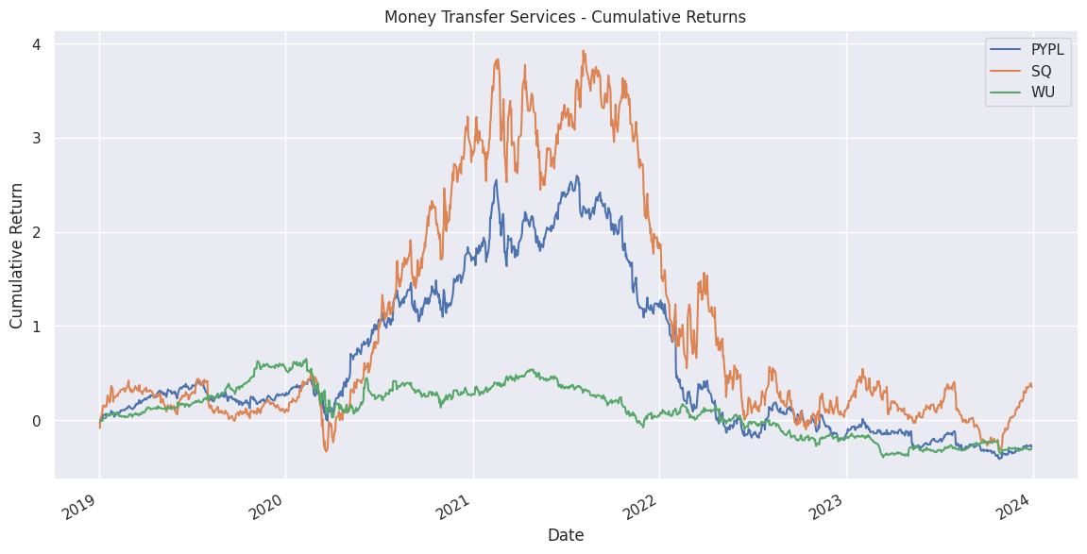**Inference:**

* PayPal and Square show substantial cumulative returns, highlighting their strong performance over time.
* PayPal’s cumulative returns indicate significant growth, particularly during periods of high digital payment adoption.
* Square’s cumulative returns follow a similar pattern, reflecting its success in the fintech space.
* Western Union shows modest cumulative returns, indicating steady but slower growth.
* The cumulative returns illustrate the high growth potential of PayPal and Square compared to the stability of Western Union.

**Graph 8:** Wire Transfer Services - Cumulative Returns:

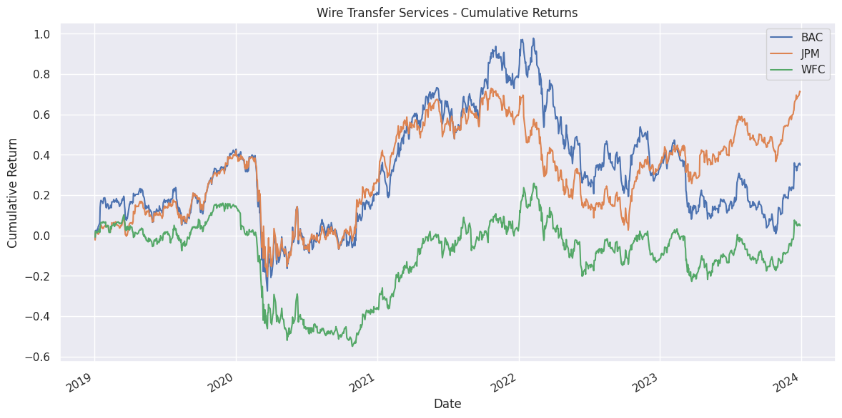**Inference:**

* JPMorgan Chase, Bank of America, and Wells Fargo exhibit steady cumulative returns, reflecting consistent long-term growth.
* JPMorgan Chase shows gradual cumulative returns, indicating steady value creation over time.
* Bank of America’s cumulative returns are similar, reflecting reliable performance.
* Wells Fargo’s cumulative returns are slightly more variable but still show long-term growth.
* The steady cumulative returns of these banks make them attractive for long-term investors seeking consistent performance.

**Conclusion:**

In conclusion, Money Transfer Services and Wire Transfer Services are integral components of the US banking sector, each catering to different needs with unique advantages. Money Transfer Services, driven by digital innovation from companies like PayPal and Square, offer quick, convenient, and accessible options for both peer-to-peer and business transactions. These services are transforming the landscape with technologies like blockchain, enhancing security and reducing costs. On the other hand, Wire Transfer Services remain the gold standard for high-value and cross-border transactions due to their reliability, speed, and robust security measures. Despite their higher costs, wire transfers are crucial for real estate, corporate payments, and investment transactions. Both the services face evolving regulatory environments, requiring compliance with AML and KYC regulations to ensure security and trust. The integration of these services within traditional banking apps and the emergence of fintech partnerships are creating comprehensive financial ecosystems. As technology advances, the synergy between Money Transfer Services and Wire Transfer Services will continue to drive innovation, efficiency, and growth in the financial sector, meeting diverse customer needs in an increasingly digital economy.